**Step 1**

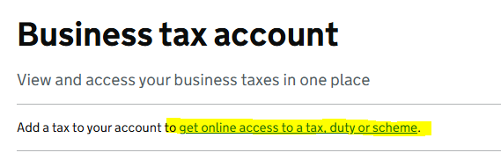

**Step 2**

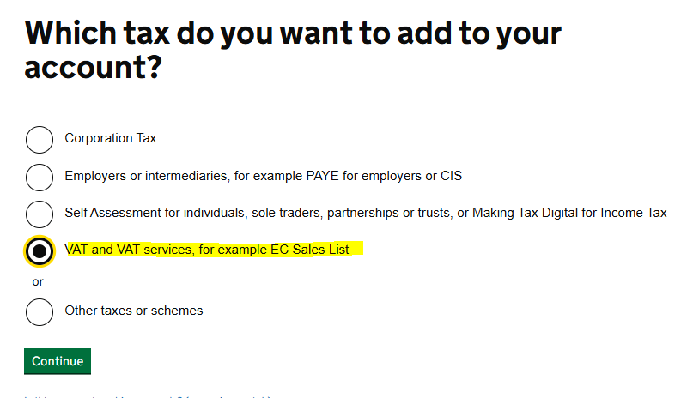

**Step 3**

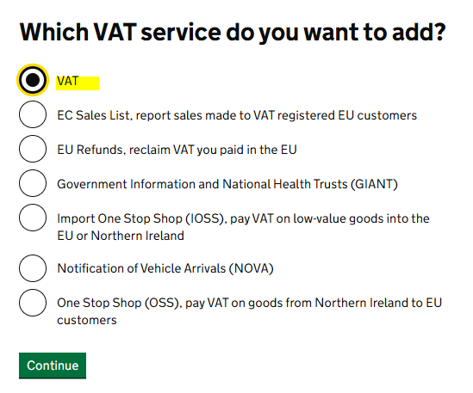

**Step 4**

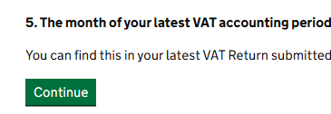

**Step 5**

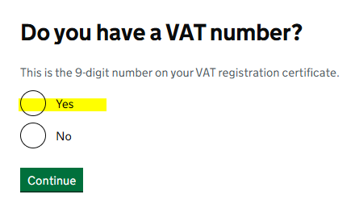

**Step 6 – enter your VAT number (can be taken from letter from HMRC)**

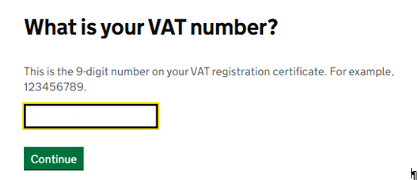

**Step 7 – what date you register from (can be taken from letter from HMRC)**

